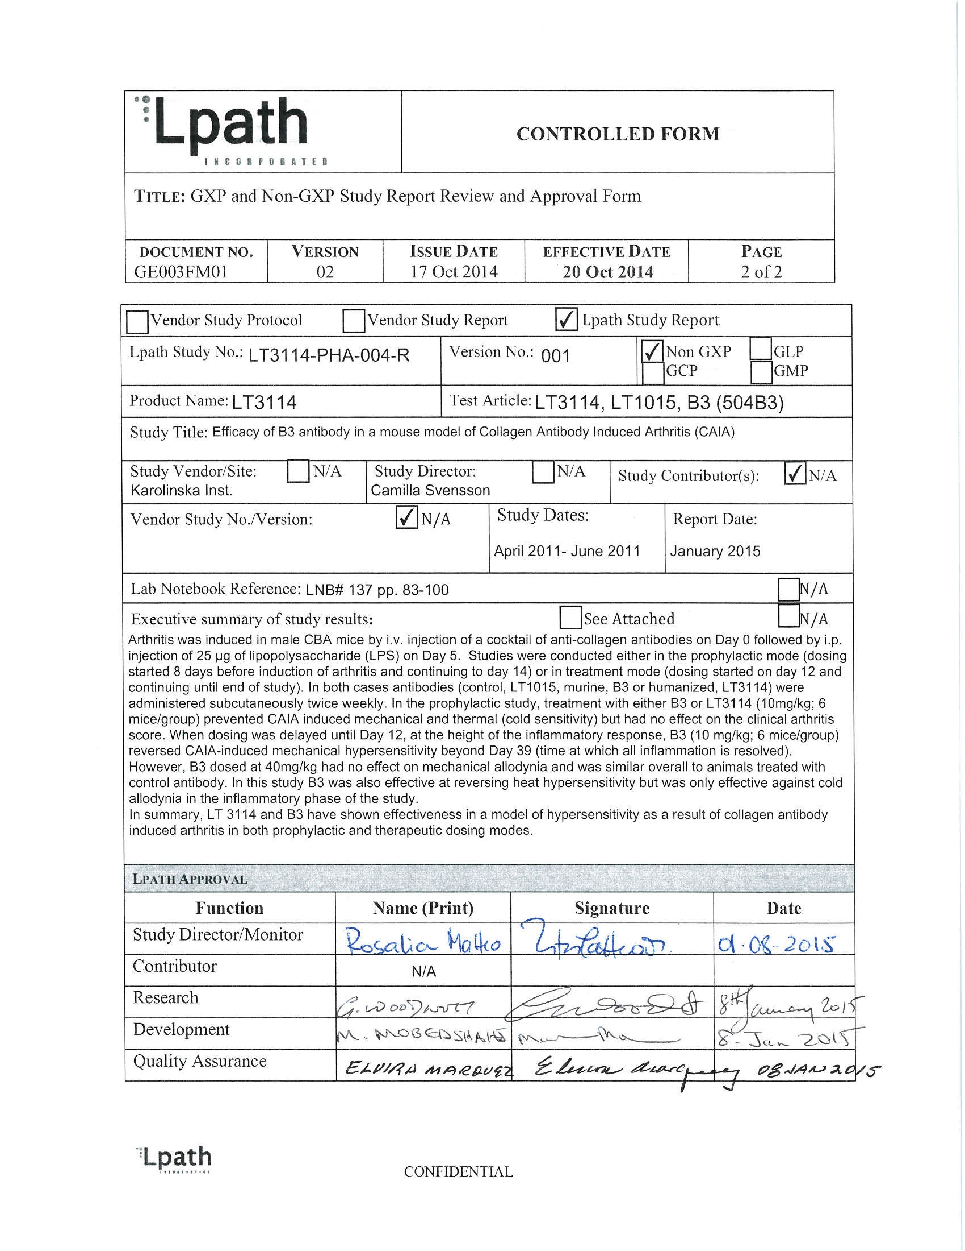
Image page 1 #1
Study Number: LT3114-PHA-004-R Title: Efficacy of B3 antibody in a mouse model of Collagen Antibody Induced Page 1 of 16 Arthritis (CAIA) Efficacy of B3 antibody in a mouse model of Collagen Antibody Induced Arthritis (CAIA) Document Type Final Report Study Monitor Rosalia Matteo Study Director Camilla Svensson Performance Site (s) Karolinska Institute Initiation Date 04-2011 Completion Date 06-2011 FSR January 2015 GLP, GMP or GCP Non- GLP Number of Pages 16 Description Test Article Murine Anti-LPA antibody/ B3 Archive Karolinska Institute /Lpath CONFIDENTIAL
Table (source: module4_extracted/Efficacy of B3 antibody in a mouse model of Collagen Antibody Induced Arthritis (CAIA)/tables/table_page_2_idx_1.csv)
0
1
Study Number: LT3114-PHA-004-R: Efficacy of B3 antibody in a mouse model of Collagen Antibody Induced(CAIA)
Page 1 of 16
Study Number: LT3114-PHA-004-R Title: Efficacy of B3 antibody in a mouse model of Collagen Antibody Induced Page 2 of 16 Arthritis (CAIA) TABLE OF CONTENTS 1 SUMMARY ………………………………………………………………………………………………………..4 2 INTRODUCTION ……………………………………………………………………………………………….5 3 MATERIALS AND METHODS ……………………………………………………………………………5 3.1 Test Article and Control……………………………………………………………………………….5 3.2 Study Design ………………………………………………………………………………………………6 3.2.1 Prophylatic treatment ………………………………………………………………………….6 3.2.1.1 Experimental outline (prophylactic treatment) ………………………………6 3.2.1.2 Experimental outline (Therapeutic intervention) ……………………………6 3.3 Experimental outline (therapeutic treatment) ………………………………………………….7 3.4 Clinical scores of arthritis …………………………………………………………………………….8 3.5 Tactile Response Threshold ………………………………………………………………………….8 3.5.1 Modified cold allodynia testing (ACETONE SCALE) ……………………………8 3.5.2 Thermal allodynia ………………………………………………………………………………9 3.5.3 Immunohistochemistry ……………………………………………………………………….9 3.5.4 Image Analysis and Quantification ……………………………………………………….9 3.6 Data Analyses …………………………………………………………………………………………..10 4 RESULTS …………………………………………………………………………………………………………10 5 CONCLUSIONS………………………………………………………………………………………………..16 6 DATA ARCHIVE ………………………………………………………………………………………………16 7 REFERENCE …………………………………………………………………………………………………….16 LIST OF IN-TEXT FIGURES Figure 1 Effect of pre-treatment of B3 and 3114 on CAIA-induced mechanical hypersensitivity (A) joint inflammation (B) and cold allodynia (C). ……..11 Figure 2 Effect of delayed dosing of B3 on CAIA-induced joint inflammation (A) and mechanical hypersensitivity (B). …………………………………………..12 Figure 3 Effect of post-treatment of B3 on heat hypersensitivity (A) and cold allodynia (B). …………………………………………………………………………………12 Figure 4 Systemic treatment with B3 reduces CAIA-induced up-regulation of α2δ1 in DRGs. ……………………………………………………………………………….13 Figure 5 Systemic treatment with B3 reduces CAIA-induced up-regulation of P2X3 in DRGs ……………………………………………………………………………….13 Figure 6 Systemic treatment with B3 reduces CAIA-induced up-regulation of galanin in DRGs. …………………………………………………………………………….14 CONFIDENTIAL
Table (source: module4_extracted/Efficacy of B3 antibody in a mouse model of Collagen Antibody Induced Arthritis (CAIA)/tables/table_page_3_idx_1.csv)
0
1
Study Number: LT3114-PHA-004-R: Efficacy of B3 antibody in a mouse model of Collagen Antibody Induced(CAIA)
Page 2 of 16
Study Number: LT3114-PHA-004-R Title: Efficacy of B3 antibody in a mouse model of Collagen Antibody Induced Page 3 of 16 Arthritis (CAIA) Figure 7 Systemic B3 treatment does not alter GAP43 up-regulation in CAIA DRGs…………………………………………………………………………………………….14 Figure 8 Systemic treatment with B3 prevents CAIA-induced spinal astrocyte activation. ………………………………………………………………………………………15 Figure 9 Systemic treatment with B3 does not reverse microglial activation in spinal cords from CAIA mice. ………………………………………………………….15 CONFIDENTIAL
Table (source: module4_extracted/Efficacy of B3 antibody in a mouse model of Collagen Antibody Induced Arthritis (CAIA)/tables/table_page_4_idx_1.csv)
0
1
Study Number: LT3114-PHA-004-R: Efficacy of B3 antibody in a mouse model of Collagen Antibody Induced(CAIA)
Page 3 of 16
Study Number: LT3114-PHA-004-R Title: Efficacy of B3 antibody in a mouse model of Collagen Antibody Induced Page 4 of 16 Arthritis (CAIA) 1 SUMMARY This efficacy study in the collagen antibody-induced arthritis (CAIA) model was conducted at the Department of Physiology and Pharmacology and Neuroscience, at the Karolinska Institute, (Stockholm, Sweden). The purpose of the study was to demonstrate efficacy of the murine anti-lysophosphatidic acid (LPA) antibody (B3) to ameliorate CAIA-mediated mechanical and thermal hypersensitivity in the CAIA model. Arthritis was induced in male CBA mice by i.v. injection of a cocktail of anti-collagen antibodies on Day 0 followed by i.p. injection of 25 µg of lipopolysaccharide (LPS) on Day 5. Studies were conducted either in the prophylactic mode (dosing started 8 days before induction of arthritis and continuing to day 14) or in treatment mode (dosing started on Day 12 and continuing until end of study). In both cases antibodies (control, LT1015, murine, B3 or humanized, LT3114) were administered subcutaneously twice weekly. In the prophylactic study, treatment with either B3 or LT3114 (10mg/kg; 6 mice/group) prevented CAIA induced mechanical and thermal (cold sensitivity) but had no effect on the clinical arthritis score. When dosing was delayed until day 12, at the height of the inflammatory response, B3 (10 mg/kg; 6 mice/group) reversed CAIA-induced mechanical hypersensitivity beyond Day 39 (time at which all inflammation is resolved). However, B3 dosed at 40 mg/kg had no effect on mechanical allodynia and was similar overall to animals treated with control antibody. In this study B3 was also effective at reversing heat hypersensitivity but was only effective against cold allodynia in the inflammatory phase of the study. In summary, LT3114 and B3 have shown effectiveness in a model of hypersensitivity as a result of collagen antibody induced arthritis in both prophylactic and therapeutic dosing modes. CONFIDENTIAL
Table (source: module4_extracted/Efficacy of B3 antibody in a mouse model of Collagen Antibody Induced Arthritis (CAIA)/tables/table_page_5_idx_1.csv)
0
1
Study Number: LT3114-PHA-004-R: Efficacy of B3 antibody in a mouse model of Collagen Antibody Induced(CAIA)
Page 4 of 16
Study Number: LT3114-PHA-004-R Title: Efficacy of B3 antibody in a mouse model of Collagen Antibody Induced Page 5 of 16 Arthritis (CAIA) 2 INTRODUCTION The bioactive lipid lysophosphatidic acid (LPA) is a key extracellular signaling molecule in neuropathic pain. LPA and its receptors are responsible for long-lasting mechanical allodynia and thermal hyperalgesia as well as demyelination and upregulation of pain-related protein expression patterns in a variety of animal models. Evidence supports the hypothesis that antagonism of the LPA signaling pathways would benefit the treatment of neuropathic pain. We have developed the first monoclonal antibody targeting LPA (anti-LPA Ab). In preliminary studies, Lpath’s anti-LPA mAb has demonstrated efficacy in the Seltzer model of neuropathic pain where the literature has demonstrated a role for LPA in the disorder, we have also demonstrated efficacy of the anti-LPA antibody in ameliorating neuropathic pain in animals models of type 1 and 2 diabetes. We next wanted to expand the efficacy studies to explore the effect of the murine antibody, B3, hypersensitivity in a model of chronic arthritis pain. The pain that accompanies chronic rheumatoid arthritis (RA) is characterized as having both inflammatory and non-inflammatory components and this non-inflammatory component of pain shares many aspects of the neuropathic pain seen in other disease states. This pain can be reproduced in mouse models of RA including the K/BxN serum transfer model and the collagen antibody induced arthritis (CAIA) model. This study was performed in the laboratory of Dr Camilla Svensson at Karolinska Institute. Dr. Svensson has recently characterized the collagen antibody-induced arthritis (CAIA) model using pain readouts beyond the inflammatory phase of the disease and established that the antibody-induced arthritis generates persistent pain-like behavior that outlasts joint inflammation by weeks, a characteristic that mimics the human disease. Thus, these studies were undertaken to determine the efficacy of anti-LPA antibody treatment in relieving chronic non-inflammatory pain in the CAIA model. 3 MATERIALS AND METHODS 3.1 Test Article and Control Murine anti-LPA antibody (B3) Lot# HR101201 Murine IgG2b antibody (control IgG/LT1015) Lot# HR91184 Humanized anti-LPA antibody (LT3114) Lot # LP101202 CONFIDENTIAL
Table (source: module4_extracted/Efficacy of B3 antibody in a mouse model of Collagen Antibody Induced Arthritis (CAIA)/tables/table_page_6_idx_1.csv)
0
1
Study Number: LT3114-PHA-004-R: Efficacy of B3 antibody in a mouse model of Collagen Antibody Induced(CAIA)
Page 5 of 16
Study Number: LT3114-PHA-004-R Title: Efficacy of B3 antibody in a mouse model of Collagen Antibody Induced Page 6 of 16 Arthritis (CAIA) 3.2 Study Design 3.2.1 Prophylatic treatment Male CBA mice were habituated to the vivarium for 7 days after arrival. At the start of the study animals (6 animals/group) were assessed for baseline allodynia (Day -9) followed the next day (Day -8) by subcutaneous injection of LT3114, B3 or control antibody LT1015 at 10 mg/kg. Dosing continued twice a week until the end of the study. Arthritis was induced by i.v. injection of a cocktail of anti-collagen antibodies on Day 0 followed by i.p. injection of 25 µg of lipopolysaccharide (LPS) on Day 5. Allodynia and arthritis clinical scores were measured at the times detailed below. 3.2.1.1 Experimental outline (prophylactic treatment) Day -9: Baseline tactile allodynia assessed Day -8: Subcutaneous injection of LT3114, B3 or LT1015. Antibodies injected 2 times / week after this point to the end of the study. Day -7: Baseline tactile allodynia assessed Day -4: Baseline tactile allodynia assessed Day 0: Intravenous injection of collagen antibody cocktail (1.5 mg/mouse) Day 5: Intraperitoneal injection of 25 μg LPS to boost arthritis Day 7: Tactile allodynia and clinical score assessed Day 10: Tactile allodynia and clinical score assessed Day 13: Tactile allodynia and clinical score assessed Day 14: Cold hypersensitivity assessed Day 15: Tactile allodynia and clinical score assessed End of Experiment. 3.2.1.2 Experimental outline (Therapeutic intervention) Male CBA mice were habituated to the vivarium for 7 days after arrival. Over the following 9 days the mice were habituated to the experimental personnel and the testing devices. Baseline allodynia were collected every third day for three consecutive testing times prior to injection of the anti-collagen antibody cocktail. CONFIDENTIAL
Table (source: module4_extracted/Efficacy of B3 antibody in a mouse model of Collagen Antibody Induced Arthritis (CAIA)/tables/table_page_7_idx_1.csv)
0
1
Study Number: LT3114-PHA-004-R: Efficacy of B3 antibody in a mouse model of Collagen Antibody Induced(CAIA)
Page 6 of 16
Study Number: LT3114-PHA-004-R Title: Efficacy of B3 antibody in a mouse model of Collagen Antibody Induced Page 7 of 16 Arthritis (CAIA) Six groups of male CBA mice (total 36 mice) were included in the study. Five of the groups were subjected to Collagen Antibody Induced Arthritis (CAIA) by i.v. injection of a cocktail of anti-collagen antibodies on Day 0 of the study, followed by i.p. injection of 25 µg of lipopolysaccharide (LPS) on Day 5. Starting on D12 at the height of the inflammatory response, animals (6 mice/group) were treated twice weekly with control IgG (LT1015) or B3 antibody 10 or 40 mg/kg, s.c. Control groups received saline only (no CAIA, control 1), LPS but no anti-collagen antibodies (no CAIA, control 2), or anti-collagen plus LPS with saline twice weekly (CAIA). Allodynia and the degree of arthritis were assessed as described below. 3.3 Experimental outline (therapeutic treatment) Day -9: Baseline allodynia Day -6: Baseline allodynia Day -3: Baseline allodynia Day 0: Intravenous injection of collagen antibody cocktail (1.5 mg/mouse) Day 5: Intraperitoneal injection of 25 μg LPS to boost arthritis Day 6: Allodynia and clinical score were assessed Day 9: Allodynia and clinical score were assessed Day 12: Allodynia and clinical score were assessed followed by subcutaneous injection of B3 or LT1015. Antibodies were injected 2 times / week after this point to the end of the study. Allodynia was assessed at 3 and 6 h post antibody injection Day 13 (at 22h), 14, 15, 18, 21, 39, 40, 41 and 43: Allodynia and clinical score were assessed Day 47: End of Experiment. Animals were tested for allodynia prior to sacrifice and collection DRG and spinal cords At the end of the studies all tissues collected were stored for further immunohistochemical studies to explore LPA-mediated mechanisms driving CAIA-induced pain. CONFIDENTIAL
Table (source: module4_extracted/Efficacy of B3 antibody in a mouse model of Collagen Antibody Induced Arthritis (CAIA)/tables/table_page_8_idx_1.csv)
0
1
Study Number: LT3114-PHA-004-R: Efficacy of B3 antibody in a mouse model of Collagen Antibody Induced(CAIA)
Page 7 of 16
Study Number: LT3114-PHA-004-R Title: Efficacy of B3 antibody in a mouse model of Collagen Antibody Induced Page 8 of 16 Arthritis (CAIA) 3.4 Clinical scores of arthritis Arthritic clinical scores were assessed at the same time as the allodynia and grip strength measures were made. The degree of arthritis was assessed by lifting the animal and inspecting the digits, dorsal aspect of the paws and the ankle joints. Swelling was evaluated according to the scoring system below. Redness was not considered. Digits: 0-5 points (1 point for each swollen digit) Paw: 0 or 5 Ankle: 0 or 5 The maximal score per leg is 15 points. All four legs were scored; hence the maximal score per mouse was 60 points. 3.5 Tactile Response Threshold Mice were transferred to a testing cage with a wire mesh bottom and allowed to acclimate and tactile allodynia was assessed using von Frey filaments and the “up-down method” for calculation of 50% withdrawal threshold. On days where assessment of allodynia coincided with antibody treatment, the measurement of allodynia was performed first. 3.5.1 Modified cold allodynia testing (ACETONE SCALE) Sensitivity to cold is assessed with acetone drop test. One drop of acetone is applied to the plantar surface of the hind paw and the duration of the response (biting, licking or shaking) of the paw is measured over 60 seconds after the application. The test is repeated three times on each paw with a gap of 20 min between the acetone applications and the average is calculated. Based on the time spent exhibiting nocifensive behavior the following scores are given: 0: no response, 1: quick withdrawal, flick or stamp of the paw, total reaction time <1s 2: prolonged withdrawal or repeated flicking, total reaction time between 1 to 3s 3: repeated flicking of the paw total reaction time between 3 and 10s; or with licking of the paw 4: prolonged licking, total reaction time over 10 s. CONFIDENTIAL
Table (source: module4_extracted/Efficacy of B3 antibody in a mouse model of Collagen Antibody Induced Arthritis (CAIA)/tables/table_page_9_idx_1.csv)
0
1
Study Number: LT3114-PHA-004-R: Efficacy of B3 antibody in a mouse model of Collagen Antibody Induced(CAIA)
Page 8 of 16
Study Number: LT3114-PHA-004-R Title: Efficacy of B3 antibody in a mouse model of Collagen Antibody Induced Page 9 of 16 Arthritis (CAIA) The median was calculated for each hindpaw (3 times), and then the median of left and right paws was calculated (showed as final scale). 3.5.2 Thermal allodynia Heat-evoked paw withdrawal response was assessed using a device similar to that described by Hargreaves et al., (1988).1 The apparatus consists of a glass surface (maintained at 25°C) on which the mice are placed individually in Plexiglas cubicles. The thermal nociceptive stimulus originates from a focused projection bulb positioned below the glass surface. A timer is actuated by the light source, and latency was defined as the time required for the paw to show a brisk withdrawal as detected by phosphodiode motion sensors that stopped the timer and terminated the stimulus. Basal paw withdrawal latencies were assessed on three separate days prior to injection of CII-antibody cocktail or saline intravenously (day 0) and the average of these three testing defined as the baseline value. The mice were tested again day 17 and day 41 and the data expressed as % change in paw withdrawal baseline (PWL) from baseline (mean ± SEM, n = 6). 3.5.3 Immunohistochemistry Tissue sections (DRG, 12μm) were incubated with primary antibodies against galanin (rabbit, 1:4000), P2X3 (rabbit, 1:2000), CACNA2D1 (α2δ1, rabbit, 1:1000), GAP43 (rabbit, 1:1000) at 4°C overnight. Immunoreactivity (IR) was visualized with TSA Plus kit (Perkin Elmer, Boston, MA). Briefly, the slides were rinsed in TNT buffer (0.1M Tris–HCl, pH 7.4; 0.15 M NaCl; 0.05% Tween 20) for 15 min, blocked with TNB buffer [0.5% blocking reagent (Perkin Elmer) in TNT buffer] for 30 min followed by 30 min incubation with horseradish peroxidase-labeled secondary antibody (1:200, DAKO, Glostrup, Denmark) diluted in TNB buffer. After 15 min wash in TNT buffer, all sections were exposed to fluorescein diluted in amplification solution (1:100) for 15 min, and washed in TNT buffer for 20 min. The sections were counterstained with 0.001% propidium iodide (PI, Sigma) and mounted with 2.5% DABCO (Sigma). 3.5.4 Image Analysis and Quantification Representative pictures were captured in a LSM710 confocal laser-scanning microscope (Carl Zeiss, Jena, Germany) operated with ZEN2012 software (Zeiss). Emission spectra for each dye were limited as follows: Fluorescein (505–540 nm) and PI (590-680 nm). Multi- panel figures were assembled in Adobe Photoshop CS6 software (Adobe Systems Inc., San Jose, CA). The proportion (number of immuno-positive neurons / neurons labeled by PI) of galanin, CACNA2D1, P2X3 and GAP43 positive neurons in DRGs was counted from three or four randomly selected sections at different levels (with minimum 50 μm in between). The relative IR intensity between CAIA and control DRGs in the same section was measured by Image J (NIH), while neurons with intensity more than the mean plus 2 fold of the SD of background were considered as positive. CONFIDENTIAL
Table (source: module4_extracted/Efficacy of B3 antibody in a mouse model of Collagen Antibody Induced Arthritis (CAIA)/tables/table_page_10_idx_1.csv)
0
1
Study Number: LT3114-PHA-004-R: Efficacy of B3 antibody in a mouse model of Collagen Antibody Induced(CAIA)
Page 9 of 16
Study Number: LT3114-PHA-004-R Title: Efficacy of B3 antibody in a mouse model of Collagen Antibody Induced Page 10 of 16 Arthritis (CAIA) 3.6 Data Analyses All data was generated and collected at the laboratory of Dr. Svensson at Karolinska Institute. Descriptive statistics was used to calculate median, mean, standard deviation (SD) and standard error of the mean (SEM) using Microsoft Excel. An excel spread sheet containing all data and analysis was sent via e-mail to Lpath. GraphPad Prism software (version 6.0, Graph Software inc, La Jolla, CA) was used to graph and analyze (ANOVA) the data. 4 RESULTS Anti-collagen antibody/LPS treatment induced a transient increase in arthritis score and a mechanical hypersensitivity which persisted after inflammation had completely resolved on day 39. Pretreatment of murine (B3) and humanized (LT3114) anti-LPA antibodies (from Day -8 to Day 15) prevented CAIA induced mechanical (Figure 1A) and cold (Figure 1C) hypersensitivity at day 14, but had no effect on the arthritis clinical score (Figure 1B). Therapeutic dosing with 10 mg/Kg B3 antibody (from Day 12 to Day 47) reversed CAIA-induced mechanical hypersensitivity beyond day 39 (time at which inflammation has completely resolved) (Figure 2B) with no effect on the degree of joint inflammation (Figure 2A). Treatment with control IgG (LT1015) or 40 mg/kg B3 had no impact on allodynia. (Figure 2B). Treatment with B3 antibody also reversed heat hypersensitivity in arthritic mice in both the inflammatory and the post-inflammatory phase (Figure 3A), but the antibody only attenuated CAIA-induced cold allodynia during the inflammatory phase at day 19, and not at day 44 during the post-inflammatory phase (Figure 3B). Neuropathic pain is accompanied by changes in the expression of neuronal ion channels, neurotransmitters, peptides and their receptors. To further understand the actions of anti-LPA antibodies in the amelioration of CAIA-induced pain, changes in the phenotypic pain profile of CAIA and antibody treated mice were investigated. Expression levels of the α2δ1 sub-unit of the high voltage-activated calcium channel, the purinergic 2X ionotropic receptor (P2X3), the neuropeptide galanin and the growth-associated protein 43 (GAP-43) were assessed by immunostaining. Also, it is believed that glia mediated central sensitization in the spinal dorsal horn is a mechanism for pain hypersensitivity, CAIA induced arthritis drives glia activation characterized by astrocytes (GFAP) and microglia glia (Iba-1) up regulation. Immunostaining of dorsal root ganglia (DRG) and spinal cords of CAIA mice treated in therapeutic mode from day 12 to 47 showed that systemic administration of B3 reduced CAIA-induced up-regulation of α2δ1, P2X3 and galanin in DRGs (Figures 4-6), but had no effect on GAP43 up-regulation (Figure 7). B3 also prevents CAIA-induced spinal astrocyte activation (Figure 8), but does not reverse microglial activation in spinal cords from CAIA mice (Figure 9). CONFIDENTIAL
Table (source: module4_extracted/Efficacy of B3 antibody in a mouse model of Collagen Antibody Induced Arthritis (CAIA)/tables/table_page_11_idx_1.csv)
0
1
Study Number: LT3114-PHA-004-R: Efficacy of B3 antibody in a mouse model of Collagen Antibody Induced(CAIA)
Page 10 of 16
Study Number: LT3114-PHA-004-R Title: Efficacy of B3 antibody in a mouse model of Collagen Antibody Induced Page 11 of 16 Arthritis (CAIA) These data suggest that blocking the action of systemic LPA reverses arthritis-induced hypersensitivity both during the inflammatory and post-inflammatory phase, potentially through regulation of P2X3 and galanin expression in peripheral neurons and astrocyte activation in the central nervous system. Figure 1 Effect of pre-treatment of B3 and LT3114 on CAIA-induced mechanical hypersensitivity (A) joint inflammation (B) and cold allodynia (C). Each time point represents mean ± SEM, n =6 mice/group. ****p <0.0001 for CAIA + LT1015 by two-way repeated measures ANOVA with Bonferroni post-hoc analysis. p <0.05 Control vs. LT1015 and p <0.05 1015 V. B3 or 3114. Each time point represents mean ± SEM, n =6 mice/group. CONFIDENTIAL
Table (source: module4_extracted/Efficacy of B3 antibody in a mouse model of Collagen Antibody Induced Arthritis (CAIA)/tables/table_page_12_idx_1.csv)
0
1
Study Number: LT3114-PHA-004-R: Efficacy of B3 antibody in a mouse model of Collagen Antibody Induced(CAIA)
Page 11 of 16
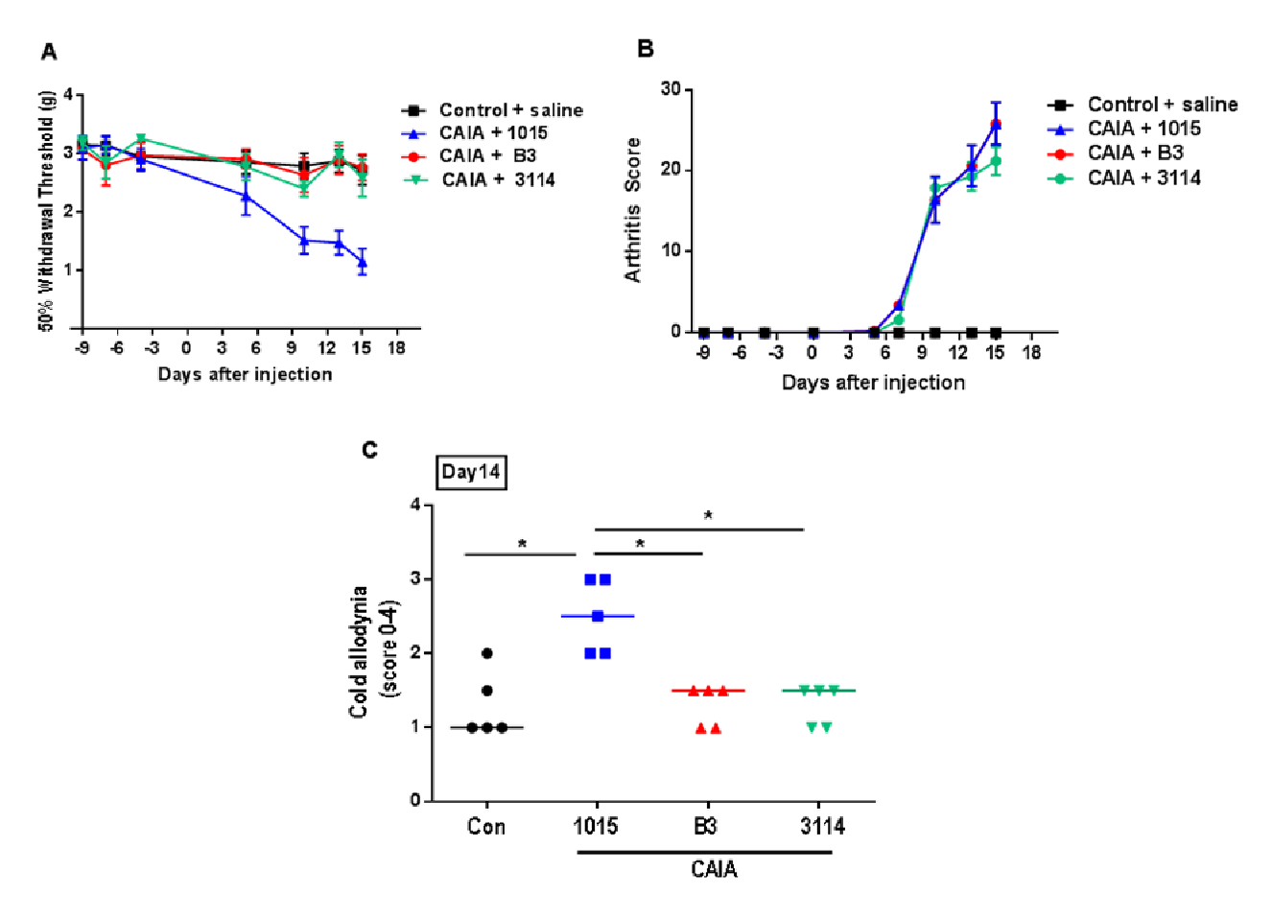
Each time point represents mean ± SEM, n =6 mice/group. ****p <0.0001 for CAIA + LT1015 by two-way repeated measures ANOVA with Bonferroni post-hoc analysis. p <0.05 Control vs. LT1015 and p <0.05 1015 V. B3 or 3114. Each time point represents mean ± SEM, n =6 mice/group.
Study Number: LT3114-PHA-004-R Title: Efficacy of B3 antibody in a mouse model of Collagen Antibody Induced Page 12 of 16 Arthritis (CAIA) Figure 2 Effect of delayed dosing of B3 on CAIA-induced joint inflammation (A) and mechanical hypersensitivity (B). p <0.05 and **p <0.001 v. CAIA + Saline by two-way repeated measures ANOVA with Bonferroni post-hoc analysis.Each time point represents mean ± SEM, n =6 mice/group. Figure 3 Effect of post-treatment of B3 on heat hypersensitivity (A) and cold allodynia (B). *p <0.05 and **p <0.01 v. CAIA + LT1015 (control Ab) by two-way repeated measures ANOVA with Bonferroni post-hoc analysis. Each time point represents mean ± SEM, n =4-6 mice/group. CONFIDENTIAL
Table (source: module4_extracted/Efficacy of B3 antibody in a mouse model of Collagen Antibody Induced Arthritis (CAIA)/tables/table_page_13_idx_1.csv)
0
1
Study Number: LT3114-PHA-004-R: Efficacy of B3 antibody in a mouse model of Collagen Antibody Induced(CAIA)
Page 12 of 16
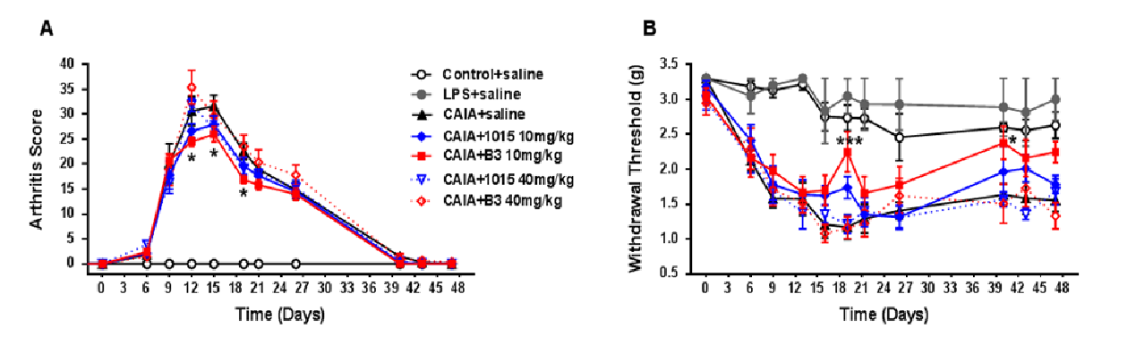
p <0.05 and **p <0.001 v. CAIA + Saline by two-way repeated measures ANOVA with Bonferroni post-hoc analysis.Each time point represents mean ± SEM, n =6 mice/group. Figure 3 Effect of post-treatment of B3 on heat hypersensitivity (A) and cold
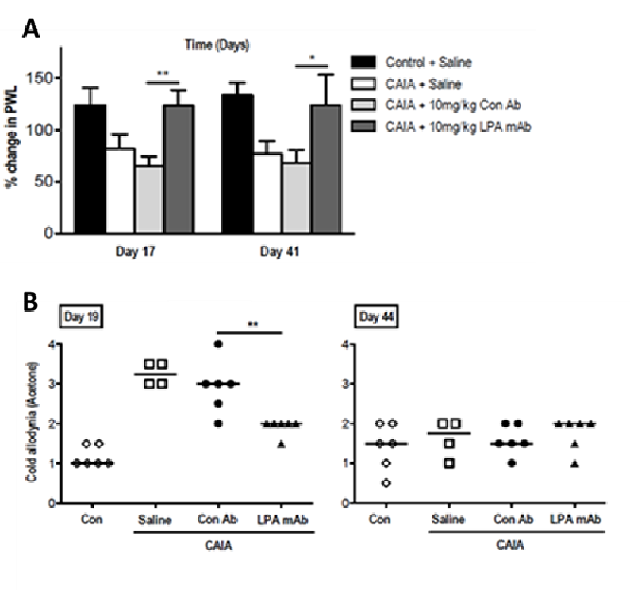
*p <0.05 and **p <0.01 v. CAIA + LT1015 (control Ab) by two-way repeated measures ANOVA with Bonferroni post-hoc analysis. Each time point represents mean ± SEM, n =4-6 mice/group.
Study Number: LT3114-PHA-004-R Title: Efficacy of B3 antibody in a mouse model of Collagen Antibody Induced Page 13 of 16 Arthritis (CAIA) Figure 4 Systemic treatment with B3 reduces CAIA-induced up-regulation of α2δ1 in DRGs. Delayed dosing with B3 (from day 12 to day 47, 10mg/kg subcutaneously injection twice a week) attenuates CAIA-induced up-regulation of α2δ1 in DRGs (day 48). A) Confocal images of α2δ1 positive neurons in mice subjected to saline, CAIA, CAIA+anti-LPA mAb treatment and CAIA+control antibody treatment on day 47 after arthritis induction. Scale bar: 20 μm B,C) Neuronal profiling of α2δ1-positive neurons in the CAIA DRGs. Both the proportion (B) and average signal intensity (C) of α2δ1 immunoreactivity-like neurons dramatically increased in the CAIA DRGs and was totally blocked by B3 treatment (n=6/group, P<0.01). Figure 5 Systemic treatment with B3 reduces CAIA-induced up-regulation of P2X3 in DRGs Delayed therapy with B3 (from day 12 to day 47, 10mg/kg, subcutaneously injection twice a week) attenuates CAIA- induced up-regulation of P2X3 in DRGs (day 48). A) Confocal images of ATP-gated ion channel P2X3-immunoreactive neurons in mice subjected to saline, CAIA, CAIA+anti-LPA mAb treatment and CAIA+control antibody treatment on day 47 after arthritis induction. Scale bar: 20 μm. B) The proportion of P2X3-positive neurons significantly up-regulated in the CAIA DRGs and was abolished by B3 treatment (n=6/group, *P<0.001). CONFIDENTIAL
Table (source: module4_extracted/Efficacy of B3 antibody in a mouse model of Collagen Antibody Induced Arthritis (CAIA)/tables/table_page_14_idx_1.csv)
0
1
Study Number: LT3114-PHA-004-R: Efficacy of B3 antibody in a mouse model of Collagen Antibody Induced(CAIA)
Page 13 of 16
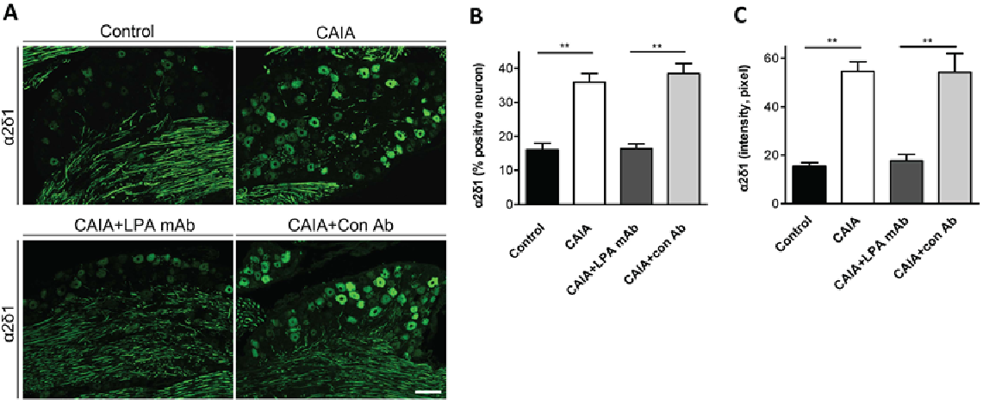
Delayed dosing with B3 (from day 12 to day 47, 10mg/kg subcutaneously injection twice a week) attenuates CAIA-induced up-regulation of α2δ1 in DRGs (day 48). A) Confocal images of α2δ1 positive neurons in mice subjected to saline, CAIA, CAIA+anti-LPA mAb treatment and CAIA+control antibody treatment on day 47 after arthritis induction. Scale bar: 20 μm B,C) Neuronal profiling of α2δ1-positive neurons in the CAIA DRGs. Both the proportion (B) and average signal intensity (C) of α2δ1 immunoreactivity-like neurons dramatically increased in the CAIA DRGs and was totally blocked by B3
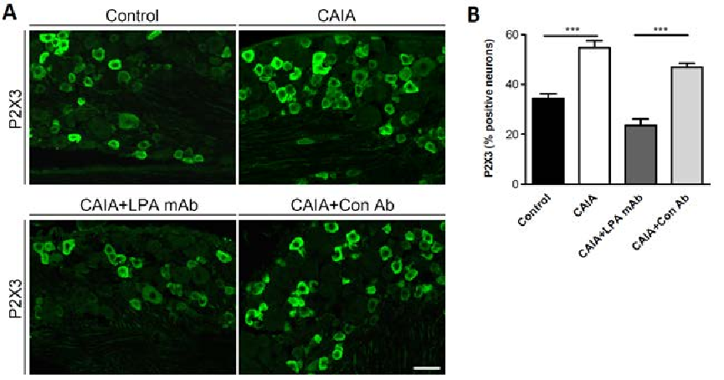
Delayed therapy with B3 (from day 12 to day 47, 10mg/kg, subcutaneously injection twice a week) attenuates CAIA- induced up-regulation of P2X3 in DRGs (day 48). A) Confocal images of ATP-gated ion channel P2X3-immunoreactive neurons in mice subjected to saline, CAIA, CAIA+anti-LPA mAb treatment and CAIA+control antibody treatment on day 47 after arthritis induction. Scale bar: 20 μm. B) The proportion of P2X3-positive neurons significantly up-regulated in the CAIA DRGs and was abolished by B3 treatment (n=6/group, ***P<0.001).
Study Number: LT3114-PHA-004-R Title: Efficacy of B3 antibody in a mouse model of Collagen Antibody Induced Page 14 of 16 Arthritis (CAIA) Figure 6 Systemic treatment with B3 reduces CAIA-induced up-regulation of galanin in DRGs. Post-treatment with LPA mAb (from day 12 to day 47, 10 mg/kg, subcutaneously injection twice a week) attenuates CAIA- induced up-regulation of galanin in DRGs (day 48). A) Confocal images of galanin immunostaining in DRG neurons of mice subjected to saline, CAIA, CAIA+anti-LPA mAb treatment and CAIA+control antibody treatment on day 47 after arthritis induction. Scale bar: 20 μm. B) The percentage of Galanin-positive neurons significantly increased in the CAIA DRGs and was blocked by B3 treatment (n=6/group, P<0.01). Figure 7 Systemic B3 treatment does not alter GAP43 up-regulation in CAIA DRGs. Delayed dosing with B3 (from day 12 to day 47, 10 mg/kg, subcutaneously injection twice a week) does not alter GAP43 up-regulation in the CAIA DRGs. The percentage of GAP43 positive neurons was pronounced elevated in CAIA mice but not affected by B3 treatment in the CAIA DRGs at day 47 (n=6/group, *p<0.001). CONFIDENTIAL
Table (source: module4_extracted/Efficacy of B3 antibody in a mouse model of Collagen Antibody Induced Arthritis (CAIA)/tables/table_page_15_idx_1.csv)
0
1
Study Number: LT3114-PHA-004-R: Efficacy of B3 antibody in a mouse model of Collagen Antibody Induced(CAIA)
Page 14 of 16
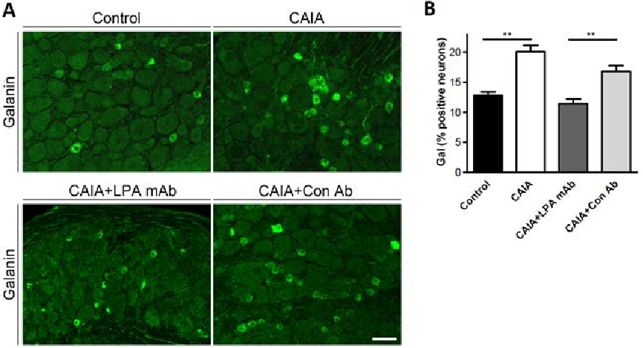
Post-treatment with LPA mAb (from day 12 to day 47, 10 mg/kg, subcutaneously injection twice a week) attenuates CAIA- induced up-regulation of galanin in DRGs (day 48). A) Confocal images of galanin immunostaining in DRG neurons of mice subjected to saline, CAIA, CAIA+anti-LPA mAb treatment and CAIA+control antibody treatment on day 47 after arthritis induction. Scale bar: 20 μm. B) The percentage of Galanin-positive neurons significantly increased in the CAIA DRGs and was blocked by B3 treatment (n=6/group, **P<0.01).
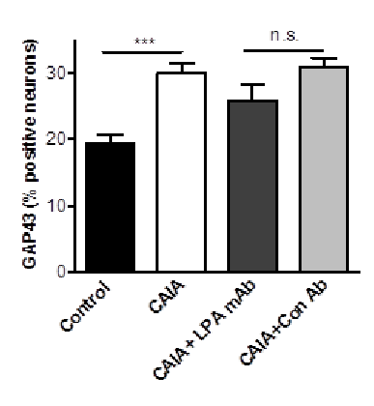
Delayed dosing with B3 (from day 12 to day 47, 10 mg/kg, subcutaneously injection twice a week) does not alter GAP43 up-regulation in the CAIA DRGs. The percentage of GAP43 positive neurons was pronounced elevated in CAIA mice but not affected by B3 treatment in the CAIA DRGs at day 47 (n=6/group, ***p<0.001).
Study Number: LT3114-PHA-004-R Title: Efficacy of B3 antibody in a mouse model of Collagen Antibody Induced Page 15 of 16 Arthritis (CAIA) Figure 8 Systemic treatment with B3 prevents CAIA-induced spinal astrocyte activation. Representative images show GFAP in the lumbar spinal dorsal horn of control CAIA mice, anti-LPA antibody-treated CAIA mice and control antibody-treated CAIA mice (A). There was a basal and mild activation of GFAP immuno-reactivity in control and CAIA mice, respectively. A significantly higher level of GFAP immuno-reactivity was observed in the superficial as well as deeper layers (lamina III-V) of spinal cord in CAIA mice treated with control antibody. Quantification of GFAP immuno-reactivity intensity in spinal dorsal horn (n = 6/group, **p<0.01 CAIA vs. control group). Figure 9 Systemic treatment with B3 does not reverse microglial activation in spinal cords from CAIA mice. Confocal images depicting Iba-1 (microglia) immuno-reactivity in the spinal cords. Iba-1 was upregulated in the CAIA group compared to control mice, while no difference between CAIA mice with anti-LPA antibody and control antibody treatment groups (n= 6/group, *p<0.05 vs control group). CONFIDENTIAL
Table (source: module4_extracted/Efficacy of B3 antibody in a mouse model of Collagen Antibody Induced Arthritis (CAIA)/tables/table_page_16_idx_1.csv)
0
1
Study Number: LT3114-PHA-004-R: Efficacy of B3 antibody in a mouse model of Collagen Antibody Induced(CAIA)
Page 15 of 16
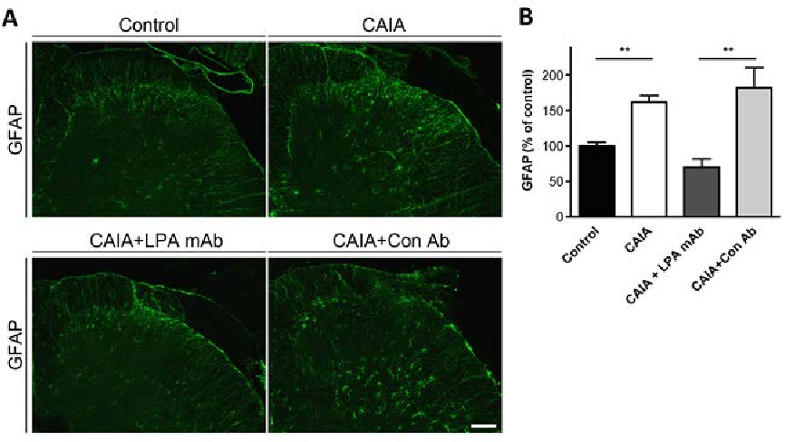
Representative images show GFAP in the lumbar spinal dorsal horn of control CAIA mice, anti-LPA antibody-treated CAIA mice and control antibody-treated CAIA mice (A). There was a basal and mild activation of GFAP immuno-reactivity in control and CAIA mice, respectively. A significantly higher level of GFAP immuno-reactivity was observed in the superficial as well as deeper layers (lamina III-V) of spinal cord in CAIA mice treated with control antibody. Quantification of GFAP immuno-reactivity intensity in spinal dorsal horn (n = 6/group, **p<0.01 CAIA vs. control group).
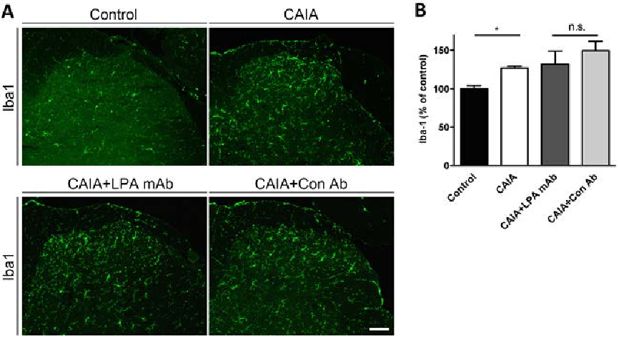
Confocal images depicting Iba-1 (microglia) immuno-reactivity in the spinal cords. Iba-1 was upregulated in the CAIA group compared to control mice, while no difference between CAIA mice with anti-LPA antibody and control antibody treatment groups (n= 6/group, *p<0.05 vs control group).
Study Number: LT3114-PHA-004-R Title: Efficacy of B3 antibody in a mouse model of Collagen Antibody Induced Page 16 of 16 Arthritis (CAIA) 5 CONCLUSIONS Pre-treatment at 10 mg/kg with the murine (B3) and humanized (LT3114) anti-LPA antibodies had no effect on arthritis score. However B3 and LT3114 prevented CAIA-induced mechanical and cold hypersensitivity Delayed therapy of B3 antibody at 10 mg/kg decreased mechanical and thermal (heat) hypersensitivity in this model of chronic arthritis pain, but in contrast 40 mg/kg dose of B3 had no effect. Interestingly B3 also improved cold hypersensitivity but only during the early inflammatory phase of the study. Systemic treatment of B3 antibody at 10 mg/kg was also effective at reversing CAIA- induced up-regulation of proteins of stress/nerve-injury markers 6 DATA ARCHIVE Lpath notebook #137 pp. 83-100 7 REFERENCE 1. Hargreaves K, Dubner R, Brown F, Flures C, and Joris J. A new and sensitive method for measuring thermal nociception in cutaneous hyperalgesia. Pain. 1988;32:77-88. CONFIDENTIAL
Table (source: module4_extracted/Efficacy of B3 antibody in a mouse model of Collagen Antibody Induced Arthritis (CAIA)/tables/table_page_17_idx_1.csv)
0
1
Study Number: LT3114-PHA-004-R: Efficacy of B3 antibody in a mouse model of Collagen Antibody Induced(CAIA)
Page 16 of 16

